Stacks homework

8- Chapter 6 described how to use recursion to convert a decimal number into

an equivalent binary number. Write a program that uses a stack to convert a

decimal number into an equivalent binary number.

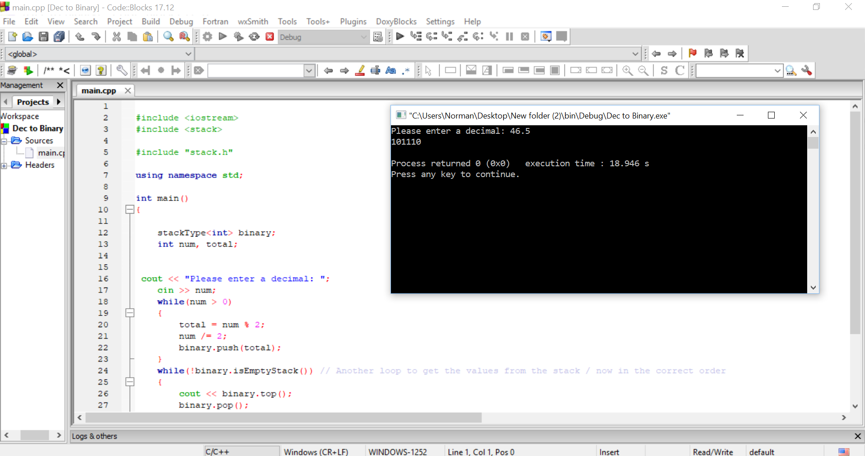

9-(Infix to Postfix) Write a program that converts an infix expression into an

equivalent postfix expression.

